AMAN SHARMA
Amankhandelwal047@gmail.com
Subject: Assignment Work of AWS Essentials Batch-1, Day-3

Project: 1
Task 1: Create a windows instance using AMI: Windows 2019 base

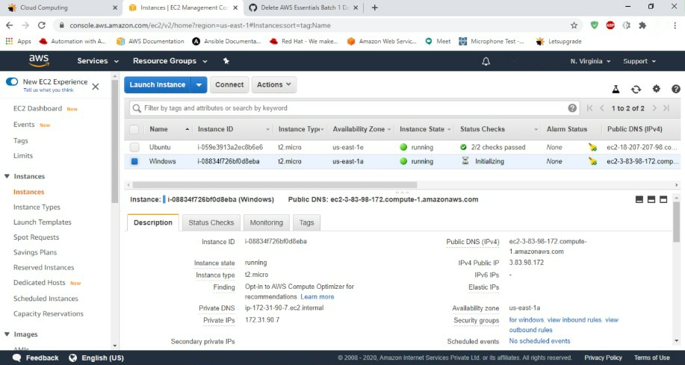
Task 2: Launch the Windows instance using RDP

Task 3: Install IIS web server using PowerShell ISE
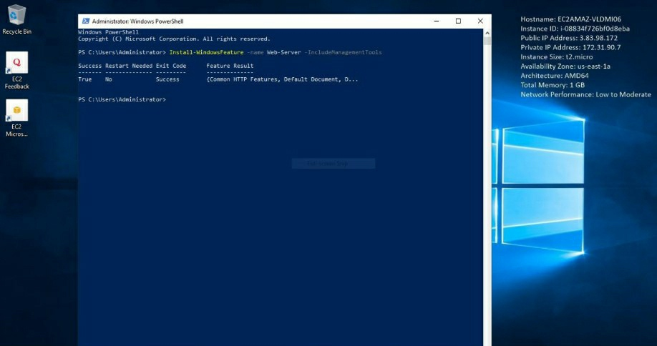

Task 4: Verify successful installation of IIS Web Server

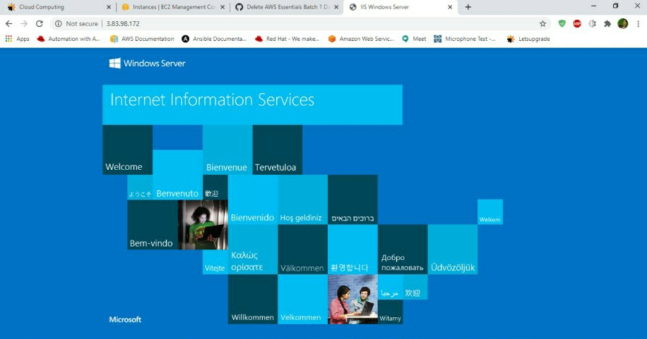

Project: 2

Public IP for Ubuntu Instance 18.207.207.98

Task 1: Create a windows instance using AMI: Ubuntu Server 18.04 LTS (HVM)

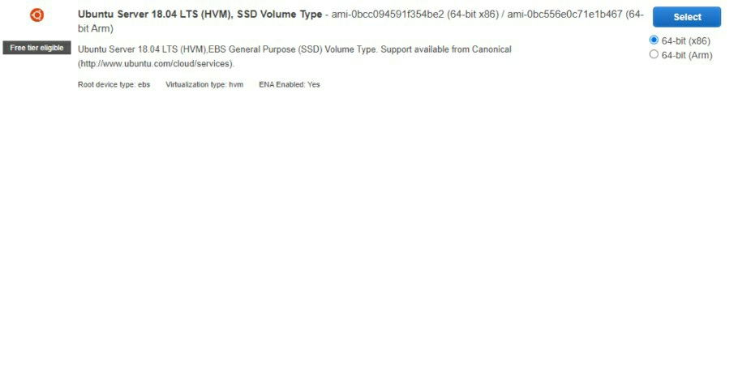

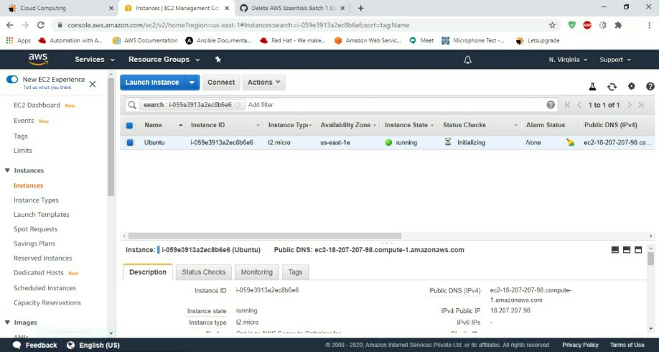

Task 2: Download and install MobaXterm Portable Edition

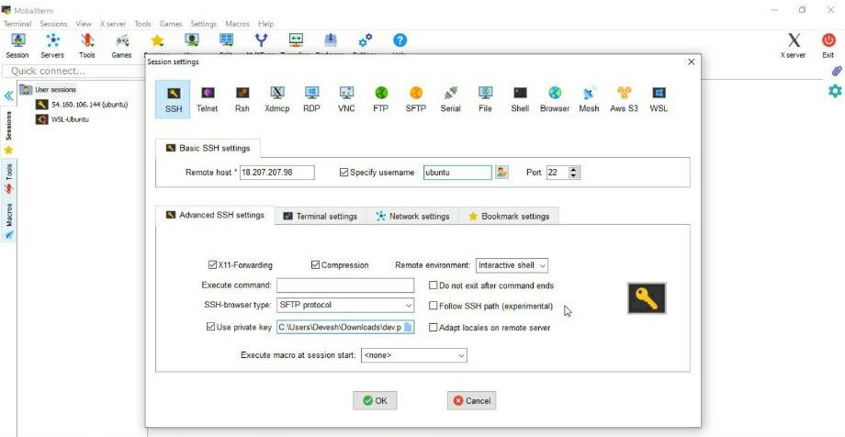

Task 3: Install ngnix web server using bash
sudo apt-get -y update sudo apt-get -y install nginx

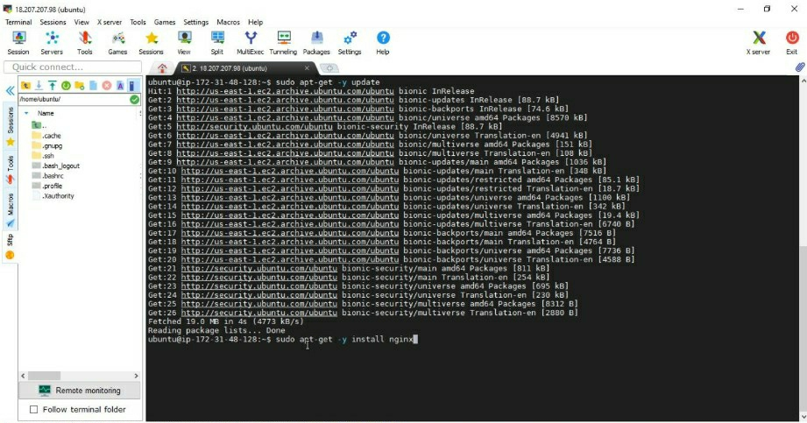

Task 4: Verify successful installation of ngnix

